OASIS Live
Friday, June 15
10 am – 2 pm
New Haven, CT location TBA

$69 Bring a friend: 2 for $99*
*Fee includes OASIS book or CD + O materials

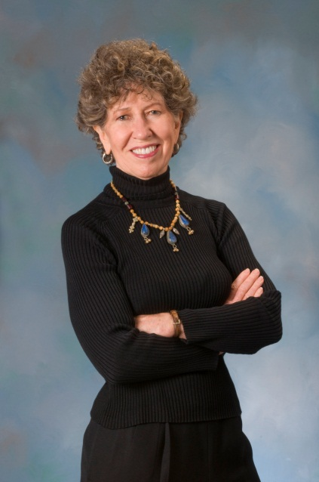
OASIS 60-second strategies are four proven strategies that work to relieve stress, remove chaos to create calm, make you healthier and happier.

OASIS is the new way of living life with peace and calmness.

Everyone today wants to be heart and mind healthy – don’t wait until it’s too late. Put OASIS into your life now. To register: 203-888-4733 or renee@milliegrenough.com

“The world gets ever more overwhelming—and Millie’s OASIS ever more essential, healing, and timely.”
David L. Katz, MD, Advisor to O, The Oprah Magazine

“A whiff of fresh air!”
D. Murali, Hindu Business Financial Daily

“Motivating! A wonderful journey!
Dan Weaver, Director of Communications,
Foxwoods Resort & Casino

Millie Grenough, OASIS originator and trainer, life coach, author of ten books, Clinical Instructor in Psychiatry at Yale University School of Medicine, and international workshop presenter/speaker.
www.milliegrenough.com

____ Yes, I want to attend the June 15 OASISLIVE! Workshop.
____ Yes, I plan to bring a friend.
Fee: 1 person $69
1 person + friend $99
3 or more Call us 203-888-4733

To help Millie customize this workshop to your specific needs,
please answer this question:

What do you want to gain from the workshop?

__________________________________________________

__________________________________________________

____ I cannot attend this workshop, but am interested in the next workshop. Please put me on your e-list to be advised
of upcoming workshops and other events.

____ Enclosed is my check for ________ made out to Oasis.
Check #________.

____ I prefer to pay by credit card or cash.
Please contact me at __________________.

Please mail this registration and payment to:

Renee O’Connell Questions?
Oasis Training Director Call Renee at
3 Old Country Road 203-888-4733
Oxford, CT 06478

Or email it to renee@milliegrenough.com

Thank you!
Millie Grenough
OASIS Originator

